Project Name: Deadlock Detection using bash script
Group Member Names:
1: Kashif Raza ( IU05-0124-0303)
2: Tehreem Aijaz ( IU05-0124-0126)

Title:
deadlock detection using wait for graph in bash

introduction
deadlock is an important concept in operating system.
deadlock happens when processes wait for each other and no process can continue.
this project detects deadlock using wait for graph.
the program is written in bash scripting language.

objective of the project
the main objectives of this project are:
- to understand deadlock concept
- to learn wait for graph
- to detect deadlock using cycle detection
- to practice bash scripting

software requirements
- linux operating system
- bash shell
- terminal

algorithm
- take number of relations as input
- read process relations (p1 p2)
- create wait for graph
- use dfs to check cycle
- if cycle found, print deadlock detected
- if no cycle, print no deadlock

code
#!/bin/bash

declare -A graph
declare -A visited
declare -A stack

detect_cycle() {
local process=$1
visited[$process]=1
stack[$process]=1

for next in ${graph[$process]}; do
if [[ -z "${visited[$next]}" ]]; then
detect_cycle "$next"
if [[ $? -eq 1 ]]; then
return 1
fi
elif [[ "${stack[$next]}" -eq 1 ]]; then
echo "Cycle Found: $process → $next"
return 1
fi
done

stack[$process]=0
return 0
}

echo "Enter number of wait-for relations:"
read n

echo "Enter relations in format: P1 P2"

for (( i=0; i<n; i++ ))
do
read p1 p2
graph[$p1]="${graph[$p1]} $p2"
done

echo "Checking for deadlock..."

for process in "${!graph[@]}"; do
if [[ -z "${visited[$process]}" ]]; then
detect_cycle "$process"
if [[ $? -eq 1 ]]; then
echo "Deadlock Detected!"
exit
fi
fi
done
echo "No Deadlock Detected!"

screenshots / output
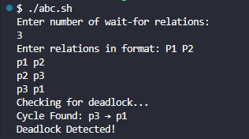
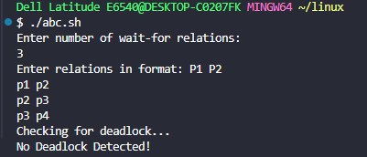

result
the program successfully detects deadlock using wait for graph.
when a cycle is present, deadlock is detected.
when no cycle is present, deadlock does not occur.

advantages
- simple and easy to understand
- detects deadlock correctly
- good for learning operating system concepts

limitations
- works for single instance resources only
- not suitable for large systems

future scope
- support multiple instance resources
- implement graphical visualization
- improve performance

conclusion
this project helps to understand deadlock detection using wait for graph.
bash scripting makes the implementation simple and clear.
the project is useful for students to learn operating system concepts.

